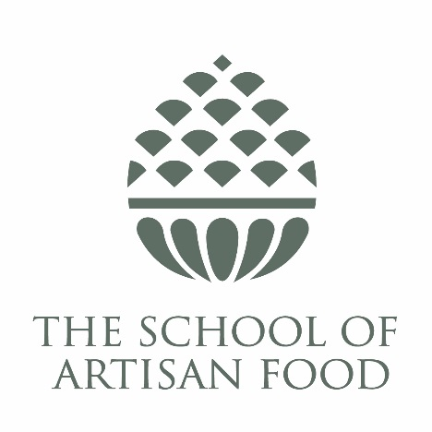
Kitchen Porter
0.5FTE – 4 hours per day (14:00–18:00), 5 days per week over 7 days including some weekends
On site.
Application Process
To apply for this position, please send maximum 2-page CV and succinct cover letter explaining how you meet the person specification (included in the Role Description & Person Specification document below) to recruitment@welbeck.co.uk no later than 5pm on Tuesday 9th September 2025, however we reserve the right to close this vacancy early if we receive a high volume of applications ahead of the advertised deadline.
If you would like to discuss this post informally, please call Jenny Paxman, Chief Executive Officer, on 01909 532171 or email jenny.paxman@schoolofartisanfood.org.
Salary and benefits
Salary for this 0.5FTE post: £12,730.48 p.a.
Holiday entitlement: 33 days inclusive of bank holiday entitlement. The Christmas Day, Boxing Day and New Year’s Day bank holidays will form part of the Christmas closure period for all employees. The School will gift additional days leave to employees for the period following Boxing Day up to and including New Year’s Eve (Christmas closure). Days will be allocated based on normal days worked.
- Contributory company pension plan
- Opportunities to access School of Artisan Food courses, additional professional development opportunities, and to gain certifications
- The Welbeck Card – 9% staff cash discount plus ‘savings points’ at Welbeck Farm Shop, The Harley Gallery and The Portland Collection
- Access to various discounts across the estate throughout the year, including School of Artisan Food Friends and Family Discounts, and discounts at Welbeck Holiday Cottages, Cuckney House, and Lady Margaret Hall bookings
- Opportunity to join Westfield Health
- Employee bike scheme
- Monthly free drink at The Welbeck Abbey Brewery on the last Friday of every month for all employees. Family and pets welcome!
Location
The School of Artisan Food, Lower Motor Yard, Welbeck, Nottinghamshire, S80 3LR
Role Description
The School of Artisan Food is a unique food education provider based on the Welbeck Estate in North Nottinghamshire. We attract students and customers from around the world to a wide range of food production courses and events. As a registered charity, we are committed to providing the widest possible access to our facilities.
We are seeking a dedicated and reliable Kitchen Porter to support our course technician and catering teams in maintaining the highest standards of cleanliness and organisation across our training kitchens and food preparation areas. This role is essential to the smooth running of our courses and events, ensuring that tutors, students, and guests experience a professional and hygienic environment.
The successful candidate will be comfortable working in a butchery environment, handling both handwashing and machine dishwashing duties, cleaning BBQs, washing pots, and maintaining surfaces and floors.
***Own transport essential***
Duties
- Wash up by hand and using dishwashing machines, ensuring all items are cleaned to a high standard and returned to their correct locations.
- Clean BBQs, butchery pots, surfaces, floors, and other equipment as required, maintaining hygiene and safety standards at all times.
- Assist with the receipt and storage of deliveries, including unpacking, stock rotation, and safe storage of ingredients and equipment.
- Maintain cleanliness and order in all kitchen and food preparation areas, including butchery and BBQ zones.
- Work collaboratively with the Course Technician and Catering teams to support course delivery and food education activities.
- Follow all School hygiene, health & safety processes and procedures, including wearing appropriate uniform and PPE.
- Participate in daily task allocation huddles and communicate effectively with colleagues to ensure smooth operations.
- Embrace the physical demands of the role, including standing for extended periods, lifting and carrying items, and working independently.
- Support other departments as needed, contributing to the overall success of The School of Artisan Food.
Person Specification
Qualifications and/or experience
 | Example | Essential/ Desirable
Experience in a kitchen or food preparation environment | Such as working in a restaurant, catering kitchen, or food education setting | D
Experience of cleaning and maintaining food preparation areas | Including handwashing and machine dishwashing, cleaning BBQs and butchery equipment | D
Understanding of food hygiene and safety standards | Or a willingness to undertake food safety training | E
Own transport | Must be able to reliably travel to and from the heart of a country estate (free parking) | E

Skills and behaviours
 | Example | Essential/ Desirable
Physical stamina and ability to meet the demands of the role | Able to stand for long periods, lift heavy items, and work in warm or cool environments | E
Willingness to work independently and take initiative | Able to manage tasks without supervision | E
Strong attention to detail and cleanliness | Maintaining high standards of hygiene in all areas | E
Ability to work collaboratively with a diverse team | Supporting tutors, technicians, and catering staff | E
Flexible and adaptable approach to work | Willing to work weekends and respond to changing needs | E
Enthusiasm for supporting food education and artisan food production | Interest in the School’s mission and values | D

